Paralysis
Frozen, motion without progress, back and forth….circles (“ringsend”); failed connections, snow,

East – West
Sight – blind
Light – Dark

Gnomon ==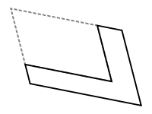 Part represents the whole, “slice of life” technique of story telling
Simony = the selling of sacred things, engaging in Bad Faith, “mauvaise foi” as Sartre called it http://en.wikipedia.org/wiki/Bad_faith_(existentialism)

Epiphany =Sudden realization, E.M. Forster “Only Connect”

